Design Document

Canvas MCP
CY2 IT Services B.V.
Date | March 2026
Version | 2.0
Status | In Development
Authors | I. Zhechev, D. Pasecinic

Version Control
Version | Date | Author(s) | Amendments
1.0 | 17/03/26 | I. Zhechev, D. Pasecinic | Initial draft with architecture diagrams.
1.1 | 19/03/26 | I. Zhechev | All chapters written. MCP tools, auth flow, security.
2.0 | 22/03/26 | I. Zhechev | Full rewrite. Aligned with project plan v1.3, removed assumptions, corrected tech stack.

Communication
Version | Date | Author(s) | Sent to
1.1 | 19/03/26 | I. Zhechev, D. Pasecinic | Koen Janssen, Patrick IJntema, Wilrik Loose
2.0 | 22/03/26 | I. Zhechev | Koen Janssen, Patrick IJntema, Wilrik Loose

Table of Contents
1. Introduction 5
1.1 Purpose 5
1.2 Scope 5
1.3 Related Documents 5
1.4 Requirements Traceability 5
2. System Architecture 7
2.1 Architectures Considered 7
2.2 Overview 8
2.3 Components 9
2.3.1 Teams Bot 9
2.3.2 LLM Service 9
2.3.3 MCP Server 9
2.3.4 Canvas API 9
2.3.5 Token Storage 9
2.4 Component Interactions 9
3. Data Flow 11
3.1 Query Processing 11
3.2 Error Handling 11
4. MCP Tool Definitions 13
4.1 get_grades 13
4.2 get_announcements 13
4.3 get_feedback 13
5. Authentication Flow 14
5.1 Two Separate Authentications 14
5.2 Initial Authorisation 14
5.3 Token Exchange 14
5.4 Token Refresh 15
5.5 Token Revocation 15
5.6 Developer Key 15
6. Adaptive Cards 16
6.1 Why Cards, Not Plain Text 16
6.2 Card Types 16
6.2.1 Grades Card 16
6.2.2 Announcements Card 16
6.2.3 Feedback Card 16
6.2.4 Error Card 16
6.3 Design Principles 16
6.4 Technical Details 16
7. Technology Stack 17
8. Security Considerations 17
8.1 Data Classification 17
8.2 Access Control 17
8.3 Input Validation 17
8.4 Network Security 18
8.5 Design Validation 18
9. References 18

1. Introduction

1.1 Purpose
System architecture and component design for Canvas MCP is what this document covers. The Research Document investigated whether the project can be built; this document specifies how the system will be built. Component interactions, data flows, authentication mechanisms, and security measures are defined here. Implementation code, API schemas, and deployment procedures are not covered.

1.2 Scope
Eight areas fall within scope: system architecture (five components and how they connect), data flow (what happens when a student asks a question), MCP tool definitions (what tools the LLM can call), authentication flow (how students connect their Canvas accounts), Adaptive Cards (how responses appear in Teams), technology stack (what frameworks and services are used), security considerations (how tokens and data are protected), and the diagrams that illustrate each of these.
Three areas fall outside scope. Implementation code belongs in the repository. Detailed API request and response schemas will be documented during development when Canvas API behaviour is tested. Deployment infrastructure specifics depend on CY2’s environment, which Koen Janssen will specify closer to delivery.

1.3 Related Documents
The Research Document answers whether Canvas MCP can be built. It covers MCP protocol mechanics, Canvas API capabilities, Teams bot requirements, LLM function calling, and OAuth2 flows. Design decisions in this document reference findings from that research.
The Project Plan defines scope, timeline, team responsibilities, and deliverables. The Stakeholder Clarification Notes record requirements confirmed by Koen Janssen, including the project framing, data priorities, and NestJS requirement.

1.4 Requirements Traceability
The Project Plan (Section 2.3) defines five functional and four non-functional requirements, formulated with the stakeholder. The table below maps each requirement to the design chapter that addresses it. Full requirement descriptions and success criteria are in the Project Plan; this section shows where each one is covered in the design.
ID | Requirement (summary) | Design Chapter | How Addressed
FR-01 | Retrieve grades across multiple courses | Ch 4 (Tools) | get_grades tool
FR-02 | Retrieve announcements, comments, assignments | Ch 4 (Tools) | get_announcements, get_feedback tools
FR-03 | Retrieve Canvas page content | Ch 4 (Tools) | Covered by get_announcements scope
FR-04 | Authenticate users via OAuth2 | Ch 5 (Auth) | Full OAuth2 flow with token storage
FR-05 | Present results in Adaptive Cards | Ch 6 (Cards) | Four card types defined
NFR-01 | Respect user-level Canvas permissions | Ch 5, Ch 8 | Scoped OAuth2, read-only access
NFR-02 | Backend built on NestJS | Ch 7 (Stack) | NestJS in tech stack table
NFR-03 | Deployable in CY2 dev environment | Ch 7 (Stack) | Docker, AKS secrets
NFR-04 | Codebase transferable via GitHub | Outside design scope | Project Plan Section 3.4

The Project Plan (Section 2.4) defines three user stories that describe end-to-end student interactions. Each maps to multiple design chapters.
US | Scenario | Requirements | Design Chapters
US1 | Student asks for course announcements | FR-02, FR-05 | Ch 3 (flow), Ch 4 (get_announcements), Ch 6 (card)
US2 | Student asks for assignment feedback | FR-02, FR-05 | Ch 3 (flow), Ch 4 (get_feedback), Ch 6 (card)
US3 | First-time OAuth2 connection | FR-04 | Ch 5 (full auth flow with card and token storage)

2. System Architecture
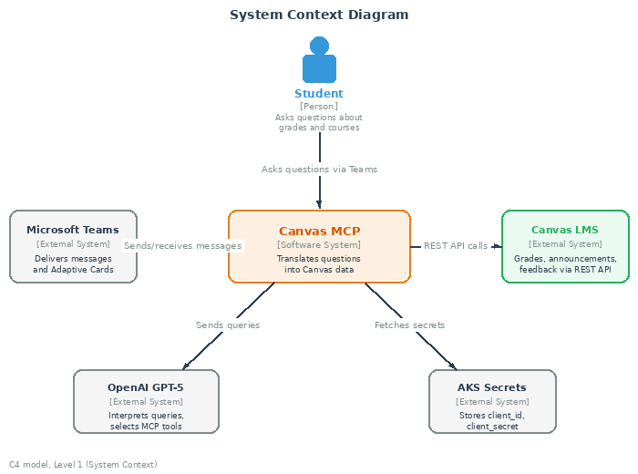
Figure 1. System context: Canvas MCP and external systems (C4 model, level 1).
// Update arrows and include token management
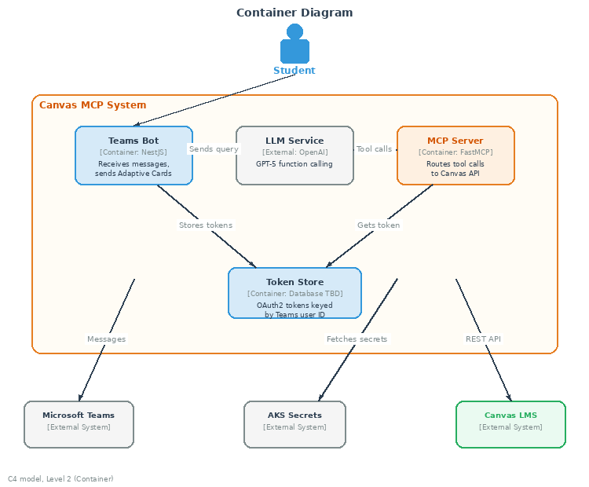
Figure 2. Containers inside Canvas MCP: Teams Bot, LLM Service, MCP Server, Token Store (C4 model, level 2).

2.1 Architectures Considered
Three architectures were evaluated before selecting the MCP-based approach. Each was assessed against four project requirements: natural language query handling (FR-01, FR-02), multi-source data retrieval (FR-03), extensibility for future CY2 integrations (Koen Janssen, 5 March), and separation between LLM and Canvas credentials (NFR-01).
Criterion | A: Direct API | B: Agent Framework | C: MCP (chosen)
NL query handling | LLM decides which hardcoded API call to run. Each endpoint must be mapped manually in code. | LLM selects from tool definitions registered in framework (e.g. LangChain). Similar to MCP but tied to one framework. | LLM selects from MCP tool definitions. Framework-independent.
Multi-source data | Adding a new data source requires new code in the bot. | Adding a tool requires code in the agent framework. | Adding a tool requires one tool definition in the MCP server.
Extensibility | No standard. Other CY2 integrations would need separate codebases. | Framework-specific. Other CY2 integrations must use the same framework. | Open protocol. Other MCP servers can run alongside Canvas MCP.
Credential separation | LLM layer and API layer share the same codebase. Tokens may be visible to LLM logic. | Depends on implementation. Some frameworks pass tokens through the LLM context. | MCP Server handles tokens. LLM never sees credentials.
Architecture A (Direct API) was rejected because it creates tight coupling between the bot and Canvas. Every new endpoint requires code changes in the bot, and the LLM layer has no structured way to discover available data sources. Anthropic described this as the M×N integration problem: connecting M different AI applications to N different tools requires M×N custom integrations (Anthropic, 2024). For a single integration this works, but CY2 plans multiple MCP integrations, so a standardised protocol matters.
Architecture B (Agent Framework such as LangChain) was considered because it provides tool registration similar to MCP. LangChain allows developers to define tools with names, descriptions, and parameter schemas that the LLM can call (LangChain, 2025). It was rejected for two reasons. First, it ties the project to a specific framework. If CY2 builds other integrations using a different stack, the tools cannot be shared. Second, Koen Janssen specified FastMCP during the stakeholder meeting, and CY2 already uses MCP for other integrations. Adopting a different framework would create inconsistency across CY2 projects.
Architecture C (MCP) was selected because it meets all four criteria. The protocol is open and framework-independent, with runtime discovery that allows clients to query servers about available tools (Model Context Protocol, 2024). Tool definitions are self-contained and can be reused across CY2 integrations. The LLM never touches Canvas credentials because the MCP Server handles authentication separately. FastMCP reduces the work to writing tool definitions only (punkpeye, 2025).

2.2 Overview
Five components make up the system. The Teams Bot receives student messages and displays responses. The LLM Service interprets questions and decides what data to fetch. The MCP Server translates LLM requests into Canvas API calls. The Canvas API returns grades, announcements, and feedback. Token Storage holds OAuth credentials so students do not have to log in repeatedly.
Why this separation? The MCP pattern keeps the LLM isolated from direct API access (Anthropic, 2024). The LLM never sees Canvas credentials and cannot make arbitrary API calls. It can only invoke predefined tools with validated parameters (Model Context Protocol, 2024). This reduces the attack surface and makes the system easier to audit.

2.3 Components

2.3.1 Teams Bot
Students interact with Canvas MCP through a chatbot in Microsoft Teams. The bot is built from scratch using NestJS and the Microsoft Bot Framework SDK (Stakeholder Clarification Notes). When a student sends a message, the bot receives it through Bot Framework channels (Microsoft, n.d.). When a response is ready, the bot formats it as an Adaptive Card and sends it back.
The bot handles two concerns that other components do not: displaying OAuth login prompts when a student has not connected their Canvas account, and rendering error messages. These are user-facing concerns that belong at the interface layer.

2.3.2 LLM Service
Natural language processing runs on OpenAI GPT-5 (OpenAI, 2020). The LLM receives the student’s question along with descriptions of available tools. Based on the question, it decides which tool to call and what parameters to pass. "What are my grades?" triggers get_grades. "Any announcements in Software Engineering?" triggers get_announcements with a course parameter.
GPT-5 was selected for its reliable function calling with fewer hallucinated parameters. GPT-5.4 mini remains available as a faster, cheaper fallback for simple queries.

2.3.3 MCP Server
The MCP Server sits between the LLM and Canvas. It receives tool calls via JSON-RPC, retrieves the student’s OAuth token from storage, calls the Canvas API, and returns results. FastMCP (a TypeScript library) handles protocol mechanics (punkpeye, 2025). The server is stateless: each request is independent, which allows horizontal scaling if needed.
Three tools are registered: get_grades for enrollment and grade data, get_announcements for course announcements, and get_feedback for teacher comments on submissions. Section 4 defines these tools in detail.

2.3.4 Canvas API
Canvas LMS exposes a REST API (Canvas LMS, n.d.). The REST API provides endpoints for enrollments (grades), announcements, and submissions (feedback). These three endpoints cover the primary use cases. Fontys hosts its own Canvas instance. API access requires a developer key issued by Fontys IT. CY2 must coordinate with Fontys to obtain this key before development can begin.

2.3.5 Token Storage
OAuth tokens must persist between requests. When a student connects their Canvas account, the bot receives an access token (valid for one hour) and a refresh token (valid until revoked). These tokens are stored in a database. The specific database provider is not yet decided. Application secrets such as client_id and client_secret are stored as AKS secrets and fetched before runtime, not in .env files. The token store schema includes: Teams user ID (primary key), access token, refresh token, token expiration timestamp, Canvas user ID, and last_active_at (updated on every successful Canvas API call, used for 30-day inactivity expiry).
Why not .env? Environment files risk accidental commits and are visible to anyone with server access. AKS secrets are managed at the infrastructure level and injected at runtime without touching the codebase.

2.4 Component Interactions
All communication between components uses HTTPS. The LLM Service is accessed via the OpenAI API directly over TLS. Canvas API calls go over the public internet to Fontys servers using TLS and bearer token authentication.
Responses flow back through the same path. Canvas returns JSON to the MCP Server. The MCP Server passes it to the LLM. The LLM generates a natural language response. The bot transforms this into an Adaptive Card and sends it to Teams.

3. Data Flow
// Mention https
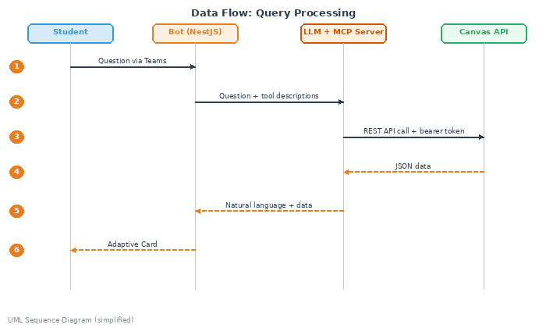
Figure 3. Query processing: six steps from question to Adaptive Card (UML sequence diagram, simplified).

3.1 Query Processing
What happens when a student asks "What are my grades in Software Engineering?" Six steps, from message to response.
Step 1: The student types the question in Teams. The message travels through Microsoft’s servers to the bot. Along with the message text, the bot receives a Teams user ID authenticated by Teams. No additional login is required.
Step 2: The bot forwards the question to OpenAI along with descriptions of the three available tools. The LLM analyses the question, selects the get_grades tool with a course filter, and outputs a structured tool call. The bot routes this call to the MCP Server via JSON-RPC.
Step 3: The MCP Server retrieves the student’s OAuth token from the database, checks expiration, and calls the Canvas Enrollments API with the bearer token.
Step 4: Canvas returns enrollment data as JSON, including the student’s grade.
Step 5: The MCP Server passes the data back to the LLM, which generates a natural language response incorporating the grade information.
Step 6: The bot transforms this response into an Adaptive Card with the course name, percentage, letter grade, and a link to the full gradebook. Teams renders the card in the chat.

3.2 Error Handling
Four failure modes are handled explicitly.
No Canvas authorisation: The token lookup in Step 5 finds nothing. The student has never connected their Canvas account. The MCP Server returns an error, and the bot displays an OAuth login card with a button to start the authorisation flow.
Canvas API error: The API returns a 500 error or rate limit response. The MCP Server propagates this error to the LLM. The LLM generates an appropriate error message rather than fabricating grade data.
Token refresh failure: The refresh token is invalid because the student revoked access in Canvas settings. The MCP Server returns an authorisation error, and the bot prompts for re-authorisation.
Ambiguous query: The student asks "What are my grades?" without specifying a course. The LLM might return all grades, ask for clarification, or pick the most recently active course. Behaviour depends on prompt engineering during development.

4. MCP Tool Definitions
// Add all the tools
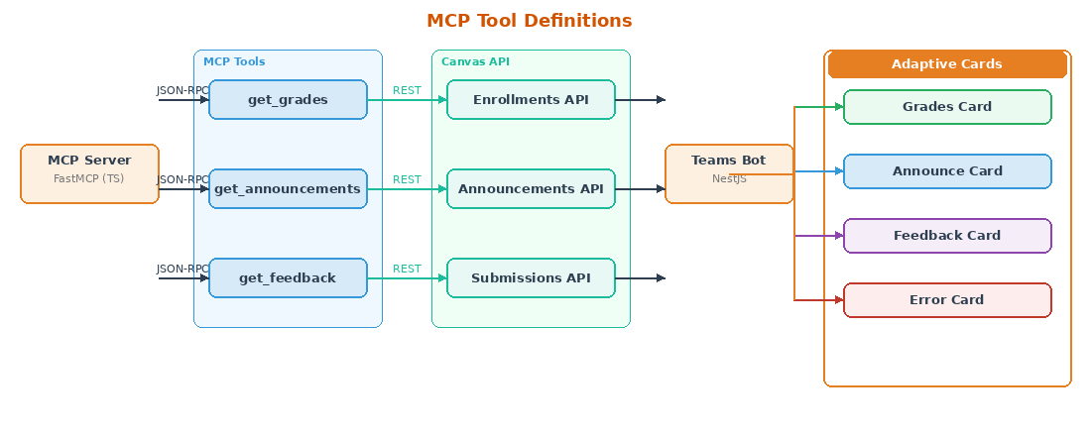
Three tools are registered with the MCP Server. Each tool maps to one or more Canvas REST API endpoints. The LLM sees tool descriptions and decides which to call based on the student’s question.

4.1 get_grades
Returns enrollment and grade information. When a student asks about grades, marks, scores, or academic standing, this tool is called. The Canvas Enrollments API provides current score, final score, and grade letter for each course (Canvas LMS, n.d.).
Parameters: course_id (optional). If provided, returns grades for that specific course. If omitted, returns grades for all enrolled courses.
Returns: A list of enrollments. Each enrollment includes course name, course code, current score as percentage, current grade as letter, and last activity date. The bot formats this into a grades card.

4.2 get_announcements
Returns course announcements. When a student asks about news, updates, announcements, or what is happening in a course, this tool is called. The Canvas Announcements API provides announcement titles, content, and posting dates (Canvas LMS, n.d.).
Parameters: course_id (optional), count (optional). If course_id is provided, returns announcements for that course only. Count limits how many announcements are returned, most recent first.
Returns: A list of announcements. Each announcement includes title, posted date, author name, and a preview of the content. Full content is available via a link to Canvas.

4.3 get_feedback
Returns teacher comments on submitted assignments. When a student asks about feedback, comments, what the teacher said, or how their assignment was graded, this tool is called. The Canvas Submissions API provides submission details including instructor comments and rubric assessments (Canvas LMS, n.d.).
Parameters: course_id (optional), assignment_id (optional). If both are omitted, returns recent feedback across all courses. If course_id is provided, limits to that course. If assignment_id is provided, returns feedback for that specific assignment.
Returns: A list of submissions with feedback. Each submission includes assignment name, submission date, score, and teacher comments. If rubric grading was used, rubric criteria and points are included.

5. Authentication Flow
// This is functionality like but it should provide instructions to infrastructure people how to run it, store tokens and etc and I can go 1 level deeper on the token store in the components diagram
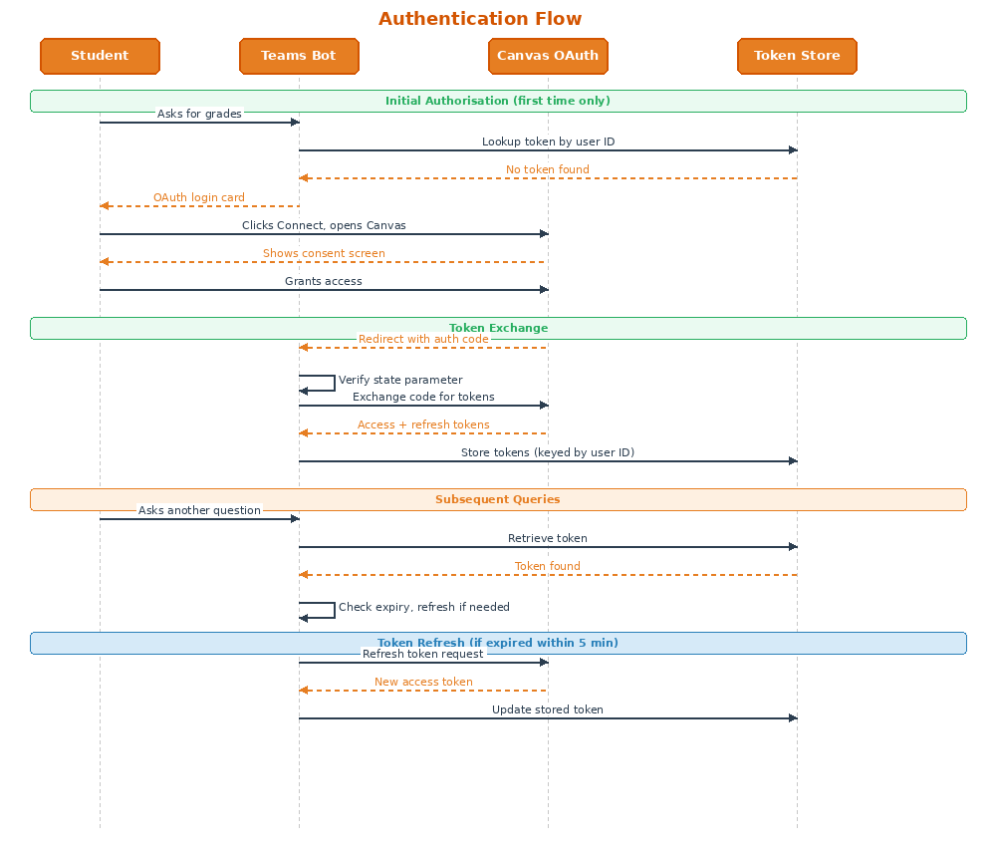

5.1 Two Separate Authentications
A common confusion: authenticating to Teams is not the same as authorising Canvas access. These are two different systems with two different credentials.
Teams authentication happens when a student opens Teams. The platform verifies their identity, and the bot receives a verified Teams user ID with each message. No additional login is required at this stage.
Canvas authorisation is separate. The Teams user ID does not grant access to Canvas data. Canvas requires its own OAuth tokens. A student must explicitly connect their Canvas account before the bot can fetch their grades.

5.2 Initial Authorisation
First time a student asks for grades, the bot has no Canvas tokens for them. The token lookup returns nothing. The bot displays an OAuth login card with a message explaining what Canvas access enables and a button to connect.
Clicking the button opens a browser window to Canvas. The URL includes the developer key ID (client_id), a callback URL, response_type=code, and a state parameter for CSRF protection (IETF, 2012). The student sees a Canvas page asking whether to allow CY2’s application to access their account.
If the student grants access, Canvas redirects to the callback URL with an authorisation code. If they deny or close the window, Canvas MCP cannot function until they authorise.

5.3 Token Exchange
The callback URL points to the bot’s server. The server verifies that the state parameter matches what it sent, protecting against cross-site request forgery. Then it sends a POST request to Canvas with the authorisation code, client_id, client_secret, and redirect_uri.
Canvas returns an access token (valid for one hour), a refresh token (valid until revoked), token type (Bearer), expiration time in seconds, and the Canvas user ID (Canvas LMS, n.d.). The server stores both tokens in the database, keyed by the student’s Teams user ID.

5.4 Token Refresh
Access tokens expire after one hour. The MCP Server checks expiration before every Canvas API call. If the token will expire within the next five minutes, the server refreshes early rather than waiting for a 401 error.
The refresh request sends the refresh token, client_id, client_secret, and grant_type=refresh_token to Canvas. Canvas returns a new access token with a fresh one-hour expiration. The same refresh token continues to work; Canvas does not issue a new refresh token on refresh.

5.5 Token Revocation
Students can revoke access at any time through Canvas settings. When they do, the refresh token becomes invalid. The next time the MCP Server tries to refresh, Canvas returns an error. The bot detects this and prompts for re-authorisation.
The application can also revoke tokens explicitly. If a student disconnects their Canvas account, the server calls Canvas’s revocation endpoint and deletes the stored tokens.

5.6 Developer Key
The entire OAuth2 flow requires a Canvas developer key from Fontys IT. The developer key provides the client_id and client_secret. Scoped developer keys limit API access to specific endpoints. Canvas MCP requests read access only: enrollments, announcements, and submissions. Write access is not requested (Stakeholder Clarification Notes).
Session duration follows an activity-based expiry policy (Session Duration Decision Record, March 2026). The session remains valid while the student actively queries Canvas MCP. After 30 consecutive days of inactivity, stored tokens are invalidated and the student is prompted to re-authorise on their next interaction. This threshold is configurable via a SESSION_INACTIVITY_DAYS environment variable so CY2 can adjust it after handover without a code change.
Every successful Canvas API call updates a last_active_at timestamp in the token store. The inactivity check runs at token retrieval, before the access token refresh check. If the threshold is exceeded, the token record is deleted and the bot shows a reconnect prompt distinct from the first-time connect message.

6. Adaptive Cards
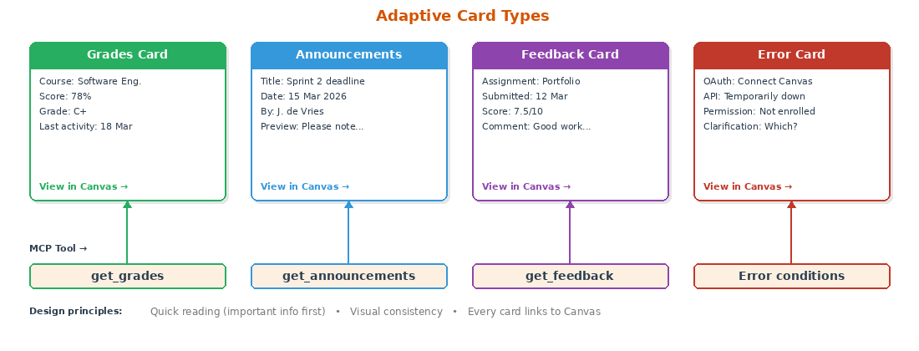

6.1 Why Cards, Not Plain Text
Plain text works for simple responses. But twelve course grades as plain text becomes a wall that students have to parse manually. Adaptive Cards solve this with structured formatting: tables for grades, headers for course names, colour coding for pass/fail (Microsoft, 2018). Cards render natively in Teams across desktop, mobile, and web. The bot sends JSON; Teams handles rendering.

6.2 Card Types
Four card types match the three MCP tools plus error conditions. Each card is designed for quick reading: the most important information appears at the top, details follow below.

6.2.1 Grades Card
Displays course grades. Columns: course name, current percentage, letter grade. Colour coding: green for passing, yellow for borderline, red for failing. A link at the bottom opens the full gradebook in Canvas.

6.2.2 Announcements Card
Displays recent announcements. Each announcement shows title, posting date, instructor name, and a content preview. Clicking the title opens the full announcement in Canvas. Announcements are sorted by date, newest first.

6.2.3 Feedback Card
Displays teacher comments on assignments. Shows assignment name, submission date, grade received, and the instructor’s feedback. If rubric grading was used, shows rubric criteria with points. Long feedback is truncated with a link to Canvas.

6.2.4 Error Card
Displays error messages and prompts. The most common error card is the OAuth prompt shown when a student has not connected their Canvas account. Other error cards handle API failures, permission errors, and clarification requests when the query is ambiguous.

6.3 Design Principles
Three rules guide card design. Quick reading matters most: important information goes at the top. Visual consistency across card types: same fonts, colours, and button placement. Every card links to Canvas: cards summarise data, they do not replace Canvas.

6.4 Technical Details
Cards are defined in JSON following the latest Adaptive Card schema supported by Teams (Microsoft, 2018). Template cards with placeholder values are stored in the codebase. The bot fills in actual data at runtime and sends the complete JSON to Teams. The Adaptive Card Designer at adaptivecards.io is used for prototyping layouts.

7. Technology Stack
Technology selections are based on Research Document findings and stakeholder requirements. The table below summarises decisions. Justifications are documented in the component sections of Chapter 2.
// Make it alphabetical
Area | Selection | Source
Language | TypeScript | Team decided (both Python and TS acceptable per Koen)
Backend | NestJS | Required (Stakeholder Clarification Notes)
MCP Framework | FastMCP (TypeScript) | Koen specified for prototype
LLM | OpenAI GPT-5 (direct API) | GPT-5.4 mini as fallback
Canvas API | REST | GraphQL migration incomplete
Token Storage | Database (provider TBD) | MCP statelessness requires persistence
Secrets | AKS secrets, fetched at runtime | Danilo confirmed, no .env files
Testing | Jest | Team decision
CI/CD | GitHub Actions | Team decision

8. Security Considerations
Canvas MCP handles OAuth tokens that grant access to student academic data. This section documents how tokens and data are protected.

8.1 Data Classification
OAuth tokens are high sensitivity: they grant access to student Canvas accounts. Tokens are never logged and transmitted only over TLS. Academic data (grades, announcements, feedback) is medium sensitivity under GDPR. This data passes through the system but is not stored; it is fetched from Canvas, formatted, and sent to the student. Operational metadata (timestamps, error codes) is low sensitivity and may be logged for debugging.

8.2 Access Control
Each student accesses only their own data. The MCP Server retrieves tokens by Teams user ID. There is no mechanism for one student to request another student’s grades. The Canvas developer key requests read-only scopes: enrollments, announcements, and submissions. Write access is not requested. Even if tokens were compromised, an attacker could read but not modify data.

8.3 Input Validation
User queries pass through the LLM before reaching the MCP Server. The LLM extracts structured parameters; the MCP Server validates them via Zod schemas (punkpeye, 2025). Canvas API calls use parameterised requests, not string concatenation with user input. Injection attacks are prevented by design.

8.4 Network Security
All communication uses TLS 1.2 or higher. This includes Teams-to-bot, bot-to-OpenAI, MCP Server-to-Canvas, and database connections. Tokens appear in Authorization headers over HTTPS, never in URL parameters or logs.

8.5 Design Validation
// update
This design has been reviewed with by Patrick IJntema (Software Expert), Erik and Bardt. Feedback from that review may result in changes to the architecture, tool definitions, or security approach. This section will be updated after the meeting.

// How would I make changes in a running environment (application observation), how it will be working without REST starting over, observability, monitoring and etc. Must be more detailed

9. References
Anthropic. (2024, November 25). Introducing the Model Context Protocol. https://www.anthropic.com/news/model-context-protocol
Canvas LMS. (n.d.). Canvas REST API documentation. https://developerdocs.instructure.com/services/canvas
IETF. (2012). The OAuth 2.0 Authorization Framework (RFC 6749). https://datatracker.ietf.org/doc/html/rfc6749
LangChain. (2025). LangChain overview. https://docs.langchain.com/
Microsoft. (n.d.). Bot Framework SDK documentation. https://learn.microsoft.com/en-us/azure/bot-service/
Microsoft. (2018). Adaptive Cards documentation. https://adaptivecards.io/
Model Context Protocol. (2024, November). MCP specification. https://modelcontextprotocol.io/
OpenAI. (2020). API documentation. https://platform.openai.com/docs/guides/function-calling
punkpeye. (2025). FastMCP: A TypeScript framework for MCP servers (v3.31.0) [Software]. GitHub. https://github.com/punkpeye/fastmcp

